Project Proposal has two parts:

1. Problem
2. Introduction

This document defines the background of the problem, the existing works that are related to my research topic, the solution that I am planning to implement, and how I am supposed to address the currently facing issues. The past research interests are also explored with their limitations and the research gaps are also identified with relevant reasons. Moreover, this paper further includes the solution methodology, the software and data requirements needed to implement it, the time plan, and the risk mitigation plan for the next few months of research work.

An overall introduction to the documentation (Thesis / proposal) – you will state briefly using a paragraph what the user an expect by reading this document

1. Problem Background / Problem Domain

Nowadays, most students learn using online resources. Even though students gained knowledge in universities, schools, and other institutes, they always tend to explore more to expertise in their fields with the help of online sources. There are different types of online resources for different learning styles (visual, read and write, auditory). For example, some students may be interested in watching tutorial videos. It will help them to extract the content more than reading documentation. But some students are more interested in reading and gaining knowledge than watching a video. Sometimes we cannot identify the most suitable learning type that suits us. When someone has to be ready for an exam within two to three days, he/she has to face difficulties in finding the best learning material for a specific subject that matches their learning style. In such cases, it would be a great solution to have an online resources recommendation system by identifying our learning styles.

1. Problem Definition

Every student has a different learning style. Some students are visual learners, while some students prefer to learn through audio. The online learning system, with its range of options and resources, can be personalized in many ways. It is hard to find the perfect online material for our subject and learning style. It takes more time to try out different sources and find the relevant ones. The main issue with most online resources is reliability. Even though we found the perfect match for our choice, the information it contains may not reliable.

* 1. Problem Statement

Students are facing difficulties in finding the best online resources that match their learning styles.

4. Motivation

As a university student, I faced problems when choosing the right online sources when studying. It took me a period to find myself the best learning style that suits me. I found it by trying and following videos, reading materials, and making notes. It takes some time. In some situations, I had to watch so many tutorial videos from different sites to find the best one that meet my requirement. During the exam days, I encountered complications finding the suitable reference.

5. Existing work

Discuss existing works that are relevant to your research and directly related to the research gap you have picked to resolve in this research project

Between 5 (min) to 10 (max) papers directly related to the research gap you have picked

These existing works are used to justify the gap

|  |  |  |  |
| --- | --- | --- | --- |
| Citation | Brief => about their research in nutshell | Limitation of their research | Contributions of their research |
|  |  |  |  |
|  |  |  |  |
|  |  |  |  |
|  |  |  |  |

6. Research Gap

The suggested solution is about recommending learning resources for people with the same learning preferences using an algorithm by identifying their learning styles. The accuracy can be improved using that algorithm. The users can also suggest learning materials they followed using the feedback form

Just don’t state your research gap but also discuss in detail with justification for selecting those gaps

7. Contribution to the Body of Knowledge

7.1 Contribution to the problem domain

7.2 **Contribution to the research domain**

Note: Justify why these are actually contribution

8. Research Challenge

What is the challenge

Why it is challenging to achieve the identified research gap and make the contribution

9. Research Questions

Maximum of three questions for which you want to find the answer throughout this research

Answering the questions are your research

<https://www.scribbr.com/research-process/research-questions/>

<https://www.scribbr.com/research-process/research-question-examples/>

10. Research Aim

The aim of the research is to design, develop and evaluate <insert whatever you wishes to do>

Justification of the aim can be followed where the aim can be further elaborated

11. Research Objectives

|  |  |  |  |
| --- | --- | --- | --- |
| Research Objectives | Description | Learning Outcomes | Research Questions |
| Literature Review | R01:  R02: | L01, L06 |  |
| Requirement Elicitation | R03:  R04: | L02, L03, L04, L05, L06 |  |
| Design |  | L03, L04, L06 |  |
| Implementation |  | L03, L04, L06 |  |
| Evaluation |  | L04, L06 |  |
|  |  |  |  |
|  |  |  |  |

12. Scope of the Project

12.1 In-scope

12.2 Out-Scope

12.3 A Diagram Depicting the prototype feature

1. Methodology

1. research methodology

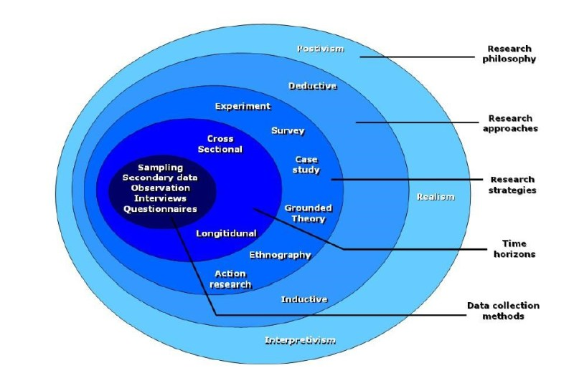

|  |  |  |
| --- | --- | --- |
| Philosophy   1. **Positivism** => if you are planning to do a quantitative research 2. **Interpretivism** => if you are planning to do a qualitative research 3. **Pragmatism** => best of the breeds | What is the philosophy you have chosen | Why do you believe that is the best philosophy for your research |
| Approach   1. **Deductive** => from the theory => hypothesis is built => data collection is done => analysis and prove or disprove the hypothesis => possible theoretical contribution is extension to the theory 2. **Inductive =>** Observation => collection data => analyze the data => build theory |  |  |
| Strategy:   1. Questionnaire (Survey):  * Qualitative * Quantitative * Mixed (used only by pragmatist)  1. Interviews  * Structured interview (based on a theme) * Semi structured * Unstructured  1. Experiments  * Obtain result by applying various metrics  1. Literature 2. Observation 3. Brainstorming 4. Focus group testing (applicable for evaluation of your prototype/MVP) |  |  |
| Choice:   1. Mono method => only one method to be used to collect data 2. Multi method => more than one method but all belongs to same paradigm (Functionalist (Quan)/interpretivist(qual)) 3. Mixed method => one from functionalist paradigm and one from interpretivist (you are mixing the method => only possible when you choose pragmatism) |  |  |
| Time horizon   1. Cross sectional – once in time frame 2. Longitudinal – data collected and linked in two different time frames |  |  |
| Sample size  >= 100 can use questionnaire  < 100 can use interviews in that case 5 to 30 interview |  |  |
|  |  |  |
|  |  |  |
|  |  |  |

2. Development methodology

2.1 What is the development methodology

1. **prototyping**

2. one person agile methodology

2.2. Requirement elicitation methodology

a) survey

- interview

- questionnaire

b) literature review

c) experiment

d) observation

e) brainstorming

…

* 1. Design methodology

1. OOAD
2. SSADM
   1. Development methodology
      1. OOP
      2. Structured Programming
      3. Functional Programming
   2. Testing methodology => how are you intend to test
3. Prototype testing
4. Model testing (evaluation metrics)
5. Benchmarking
   1. **Solution methodology**
6. Project management methodology
   1. What is the project management methodology
7. Prince 2
8. Agile Prince 2
   1. Schedule

W.B. S (never part of the project proposal but needed to find the activities so you can come up with detailed activity chart)

Activity chart (never part of your project proposal => Gantt chart can only be drawn if you have an activity chart)

* + 1. Gantt chart (This is part of the project proposal => don’t make it like waterfall pls)
    2. Deliverables and dates
  1. Resource requirements
     1. Software resources
     2. Hardware resources
     3. Data requirements (if it is data science project)
     4. Skill requirements
  2. Risk and mitigation

Identify and prioritize most 5 risks you might face in completing this project on time

|  |  |  |  |
| --- | --- | --- | --- |
| Risk | Probability of Occurrence | Magnitude of the loss | Mitigation Plan |
| Not enough time to learn required know how and acquire the skills | 5 | 5 |  |
| Getting sick |  |  |  |
|  |  |  |  |
|  |  |  |  |
|  |  |  |  |
|  |  |  |  |
|  |  |  |  |

**Page count 20 to 25 not more than that**

**Note:- if the page count goes above penalty will be applied**